Digital Scrapbook

- Open Word. (Landscape or Portrait—your choice)

- Open Ask Jeeves Image.

- Think of a theme/topic you want to “scrapbook”. For example: school, friends, family, swim team, vacations, hunting, sports, etc.

- You will need to find background pictures, clip art pictures, digital pictures.

- Layer each item appropriately. After you format them, you will also need to use: “Draw”—“Order”—and choose one of the given options.

- Be creative.

- If you need help, search the Internet for scrapbook examples and ideas.

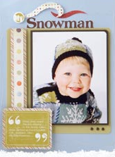
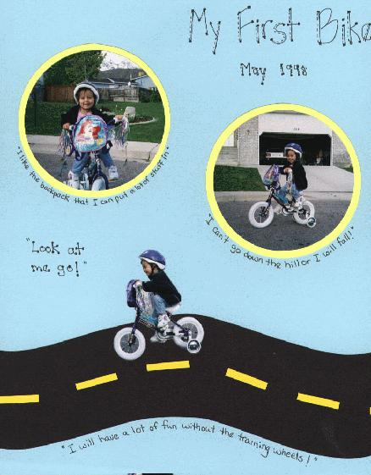
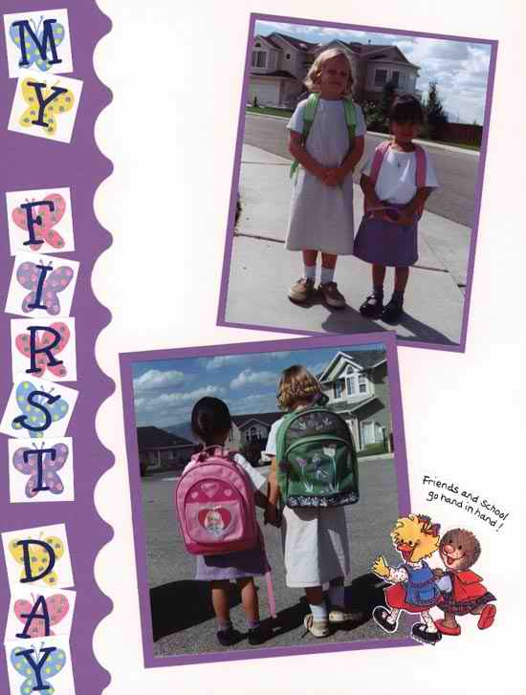
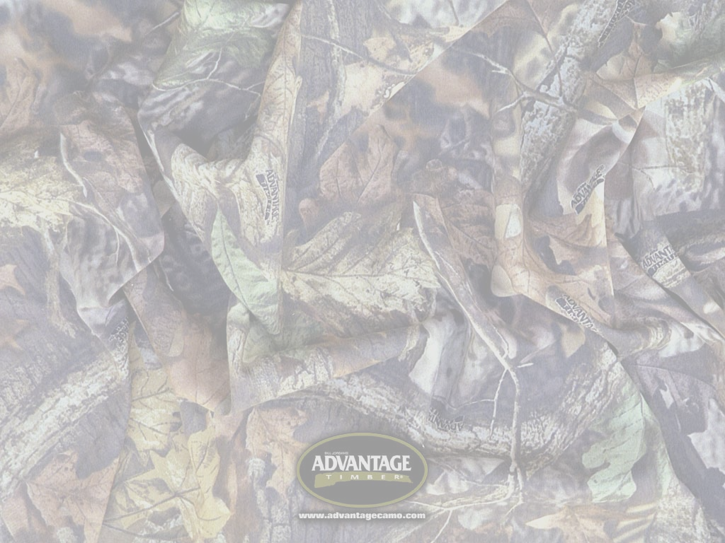

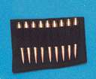
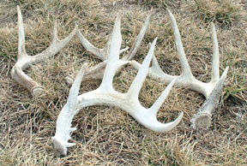
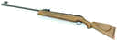
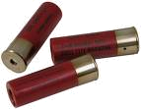
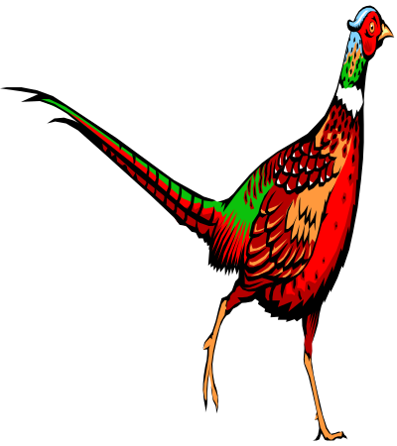
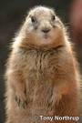
Davison Co.
2006
Roberts Co.
2006
Davison Co.
2005
2005
Charles Mix Co

